# 

# 

# 

**Populat.io**

**PROJECT COREPHASE**

DESIGN DOCUMENT

**TABLE OF CONTENTS**

**UML** **3**

**Sequence diagrams** **5**

**Use Case 1** **5**

**Use Case 2** **6**

**Use Case 3** **7**

**Use Case 4** **7**

**Use Case 5** **8**

# 

# UML

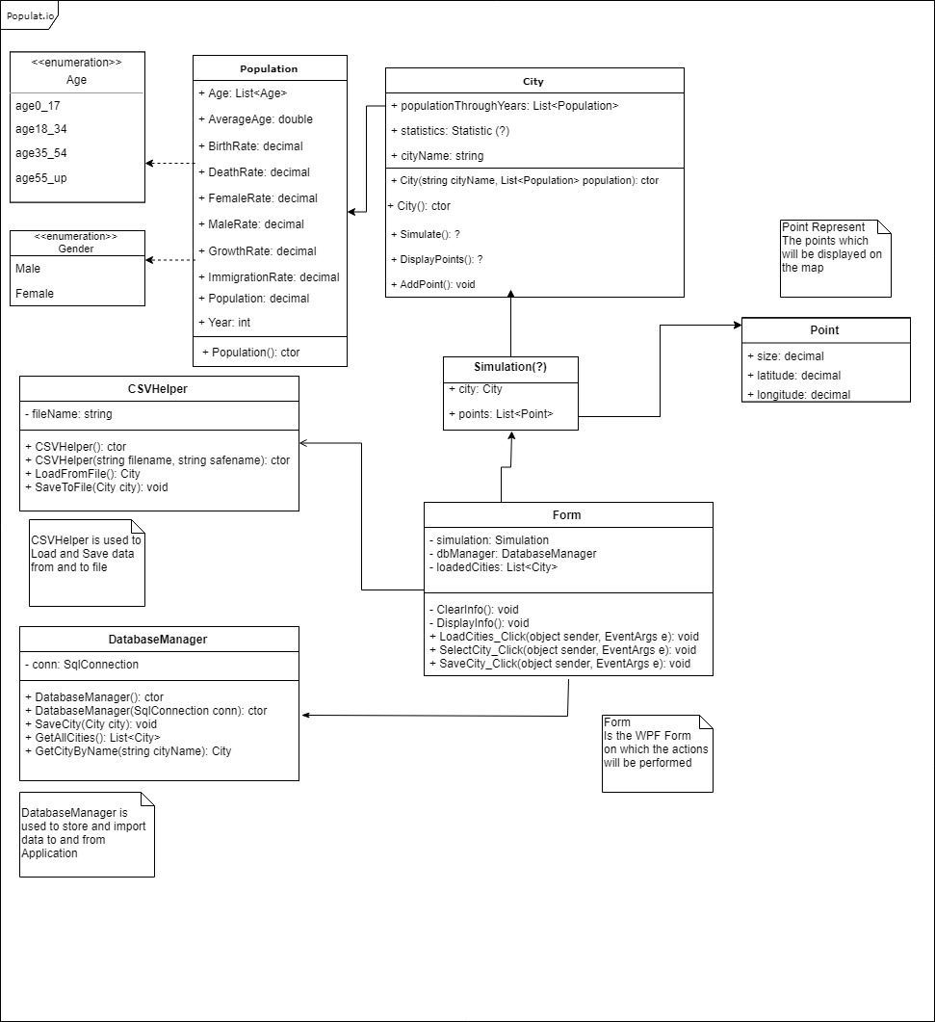

|  |  |
| --- | --- |
| **Class** | **Brief description** |
| Population | In it we store information regarding a city’s population, e.g. it’s demographical data. |
| City | Used for storing the different cities, their location and their population through the years. |
| Form | In it the interactions of the user with the application are handled. |
| Point | Represents the points that are going to be added to the map. |
| DatabaseManager | Used to store and retreive data from the database. |
| CSVHelper | Used to store and import data to and from a file. |

# Sequence diagrams

## Use Case 1

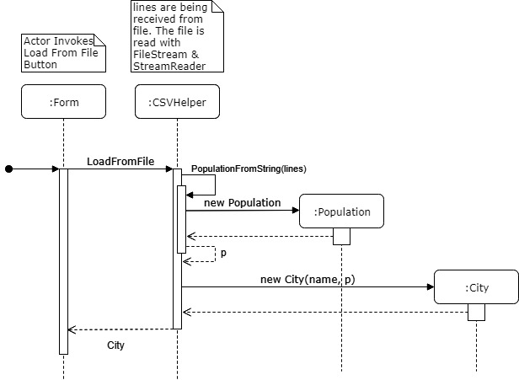

## Use Case 2

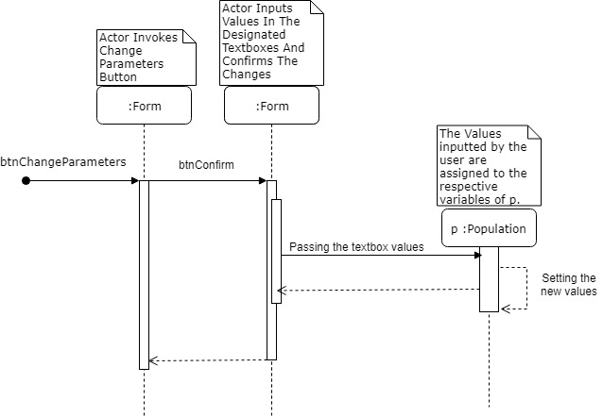

## Use Case 3

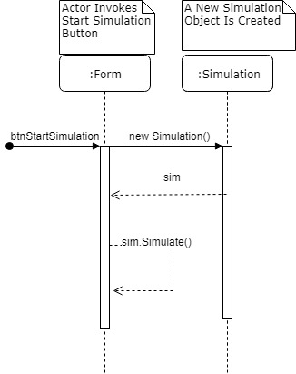

## Use Case 4

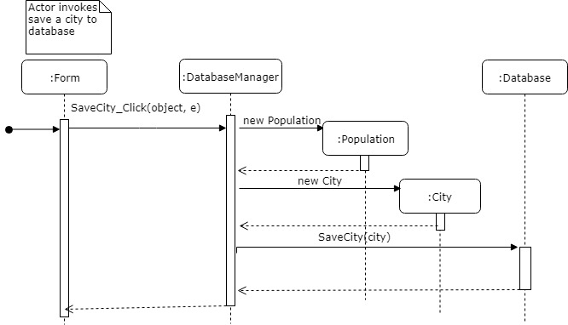

## Use Case 5

